APPROPRIATE ATTITUDE AT WORK !
What is the French for … ?
1- Take long breaks :
2- Be on time :
3- Tidy :
4- Use your mobile phones :
5- Do nothing :
6- Wear dirty clothes :
7- Be helpful :
8- Have your hands in your pockets :
9- Speak propoerly and politely :
10- Go smoking :
11- Wear suitable clothes :
12- Smile :
13- Be friendly with your colleagues :
14- Help myself and eat food :
Fill in the grid with the 14 expressions, make 2 categories. Write only numbers !
Appropriate attitude at work  = You SHOULD…/HAD BETTER TO … | Inappropriate attitude at work  =You SHOULDN’T …/HAD BETTER NOT TO …
Example : 2
La vidéo ci-dessous vous permettra de revoir l’emploi de SHOULD (vous pouvez vous arrêter à 3minutes56 !!)
https://www.youtube.com/watch?v=aZhGNeeARSw

Write 4 sentences using SHOULD or SHOULD’T and the expressions (1-14)
Example : you should be punctual / you shouldn’t be rude (=vulgaire)

1- …………………………………………………………………………………………………………………………………………………………………
2- …………………………………………………………………………………………………………………………………………………………………
3- …………………………………………………………………………………………………………………………………………………………………
4- …………………………………………………………………………………………………………………………………………………………………
GRAMMAR:

a- You should be punctual.
b- You shouldn’t be messy.
c- You’d better be polite.
d- You’d better not be rude.

Qu’expriment les mots surlignés ? Comment pourrait-on les traduire en Français ?

………………………………………………………………………………………………………………………………………………………………………
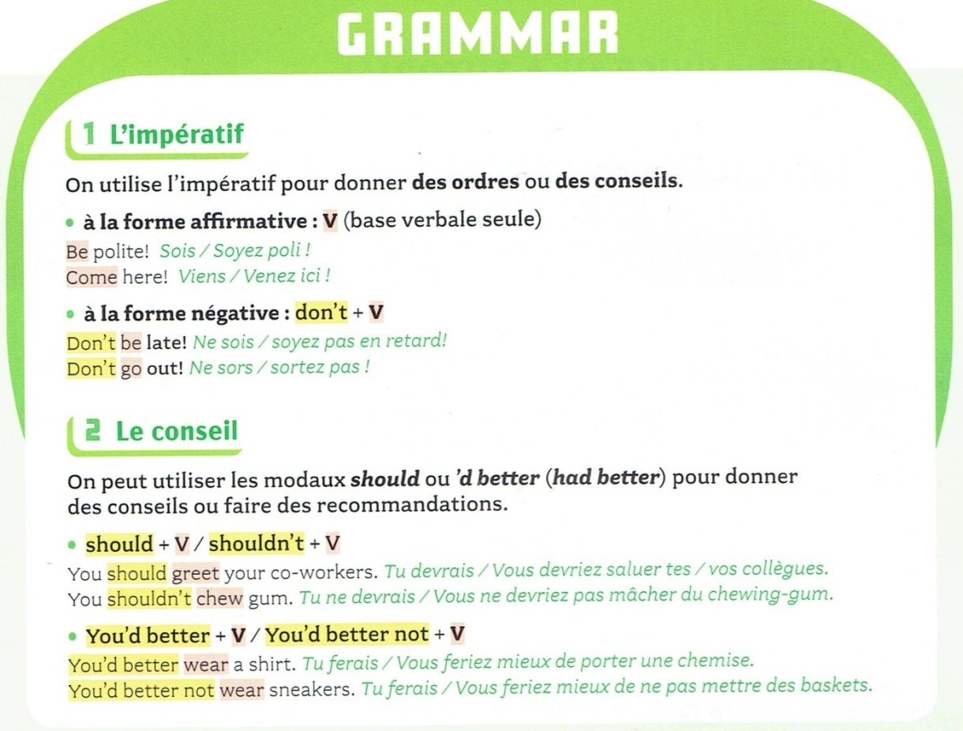

Transformer ces ordres en conseils. Utilisez SHOULD/SHOULD’T/’D BETTER TO/’D BETTER NOT TO:

1- Don’t smoke ! ……………………………………………………………………………………………………………………………………………
2- Be friendly with your colleagues ! …………………………………………………………………………………………………………….
3- Don’t wear dirty clothes ! …………………………………………………………………………………………………………………………
4- Don’t interrupt people ! ……………………………………………………………………………………………………………………………
5- Ask questions ! ………………………………………………………………………………………………………………………………………….
Mettez ces phrases à la forme négative :
1- Employees should wear colourful clothes

2- You’d better be late every day.

3- Her co-workers should interrupt their work to help her.

4- He’d better ask for money.

