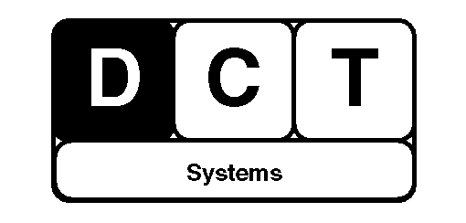

The Micro Chip Location

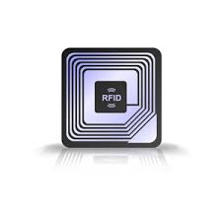

Specifications

|  |  |  |  |
| --- | --- | --- | --- |
| Resistance Values | Part 50 and 100 Ohms Series +/-5% | | |
| Frequency Range | MC0402D/W2 | DC to 30 GHz | |
| MC0505D | DC – 18.0 GHz | |
| MC0603D | DC – 18.0 GHz | |
| MC1010D | DC – 18.0 GHz | |
| Power Rating | MC0402D/W2 | | 20 Watts |
| MC0505D | | 50 Watts |
| MC0603D | | 50 Watts |
| MC1010D | | 125 Watts |
| Typical Capacitance | MC0402D/W2 | | 0.09 pF |
| MC0505D | | 0.1 pF |
| MC0603D | | 0.19 pF |
| MC1010D | | 0.8 pF |
| Operating Temperature | All | | -55°C to 150°C |
| Resistive Material | All | | Thin Film |
| Terminal Material | All | | Thin film, Gold Bondable Finish |

The MCL sales package includes

* Lion-Battery: BL – 5CB 800 mAh
* Compact Charger AC – 3
* Compact Visual User Guide

Technical Profile

* System: Universal link
* User interface: IOS/Android App
* Dimensions: 7.2mm x 0.1mm x 0.3mm (L x W x H)
* Weight: 0.2 mg (including battery)
* Connectivity: Bluetooth/WIFI

Operating times

* Standby time: Up to 178 days
* Work time: Up to 27 days

MCL Accessories

* MCL CD’s Installation
* MCL Compact Travel Charger AC -5
* MCL protection pouch