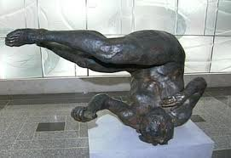

"Tumbling Woman," a statue in Rockefeller Center by Eric Fischl

Made to commemorate those who on 9/11 jumped or fell to their deaths from the World Trade Center. It was censored on 9/18/2002.

