The European Day of Language Webquest

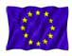 | When is the European Day of languages celebrated? Find the date of the first celebration: ......................................................................................................................................................................................
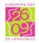 | Why is this day celebrated? .....................................................................................................................................
How many countries celebrate this day? Give examples of how some of them celebrate it.
......................................................................................................................................................................................
By the way, how many languages are there in the whole world ?
 | 2000 ? |  | 4500 ? |  | 6000 ?
Here’s a hint if you don’t find the answer.
How many countries are members of the European Union? .........................................................................
How many different languages are spoken in the Union? ..............................................................................
When was the European Union founded? ..........................................................................................................
What was its 1st name and when was this body founded?
......................................................................................................................................................................................
Describe the flag of the European Union.
......................................................................................................................................................................................
Was this flag designed especially for the Union?
......................................................................................................................................................................................
Right or wrong? Justify your answers.
 | RIGHT | WRONG
There are 27 stars on the flag.
The stars represent the member states.

How many members did the Union have in :
1957 ?
1981 ?
2004 ?

Which country presides over the European Union?
......................................................................................................................................................................................
Which are the main objectives of the EU?
......................................................................................................................................................................................
There are three institutions involved in running the EU. Name them.
......................................................................................................................................................................................
......................................................................................................................................................................................
Take the European test and see if you can do better than the average European.
What s YOUR score ? .................................................................................................................................................

Which country presides over the European Union?
......................................................................................................................................................................................
Which are the main objectives of the EU?
......................................................................................................................................................................................
There are three institutions involved in running the EU. Name them.
......................................................................................................................................................................................
......................................................................................................................................................................................
Take the European test and see if you can do better than the average European.
What s YOUR score ? .................................................................................................................................................

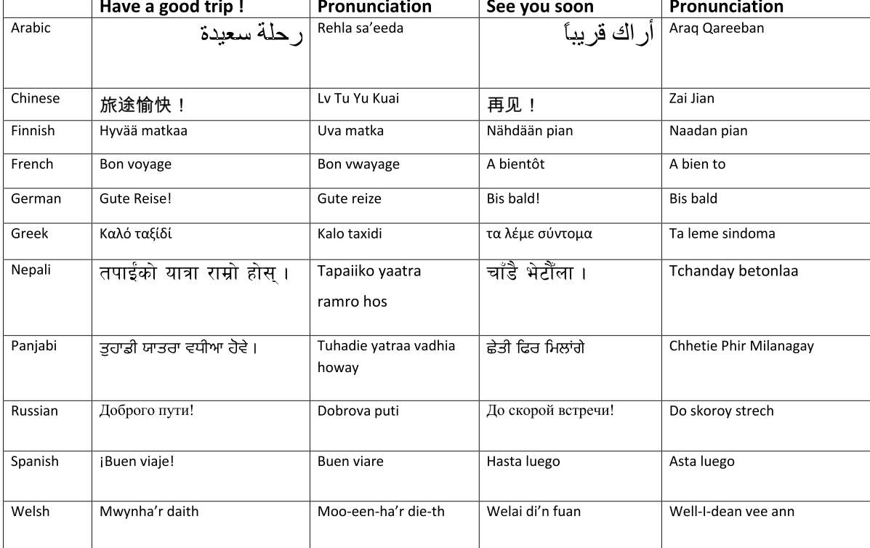

Name the countries of the European Union and their capital cities.

The European Union member states :
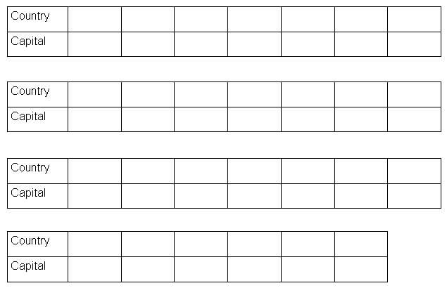

The country | Nationality | The people | The language
Austria
Belgium
Bulgaria
Cyprus
Czech Republic
Denmark
Estonia
Finland
France
Germany
Greece
Hungary
Ireland
Italy
Latvia
Lithuania
Luxembourg
Malta
The Netherlands
Poland
Portugal
Romania
Slovakia
Slovenia
Spain
Sweden
The United Kingdom

English speaking countries in the world.
Fill in the grid :
